TC-PM-004
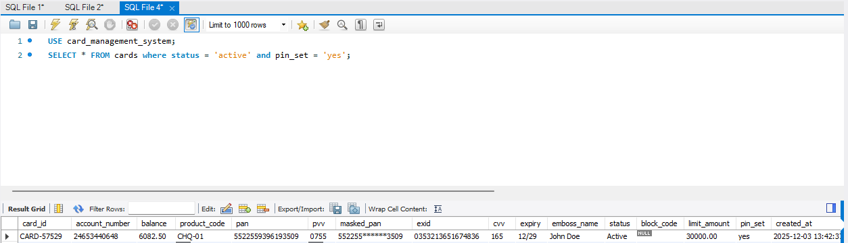
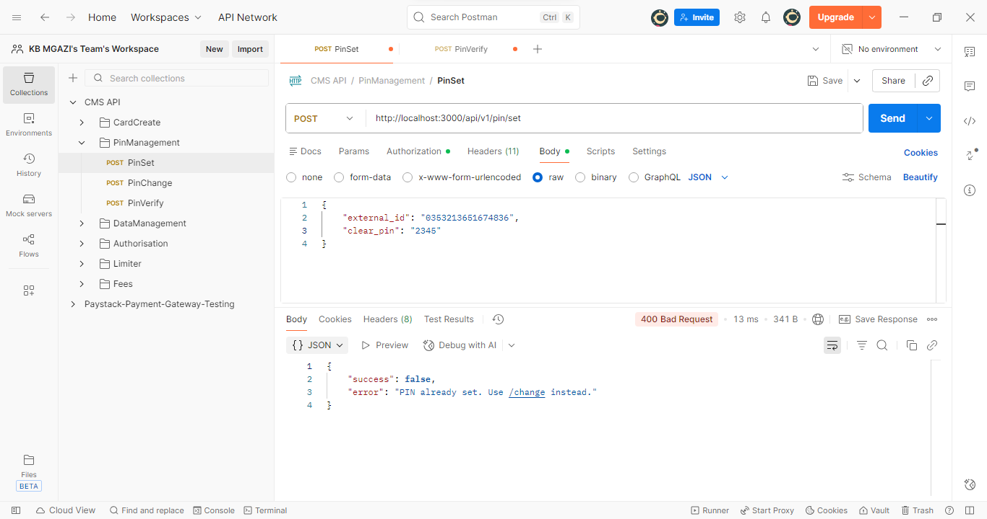
Request:
{
"external_id": "0353213651674836",
"clear_pin": "2345"
}
Response:
{
"success": false,
"error": "PIN already set. Use /change instead."
}

